**PostgreSQL installation :**

1. Please enter the following link to install the Postgresql database : <https://www.postgresql.org/download/>
2. Please make a full installation as the Vendor recommends
3. After Installing Please modify the following files to connect to the Atlassian products:
   1. Accept remote TCP connections in the following file /var/lib/pgsql/9.6/data/**pg_hba.conf**

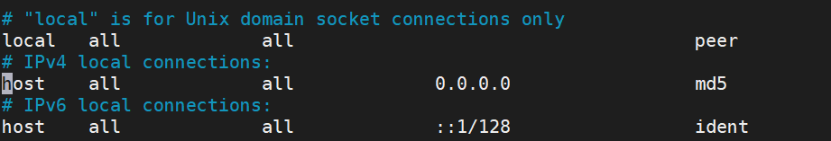

Under IPV4 category : Method = md5 , IP = please insert the Jira server IP address .

* 1. Accept remote TCP connections in the following file /var/lib/pgsql/9.6/data/postgresql.conf

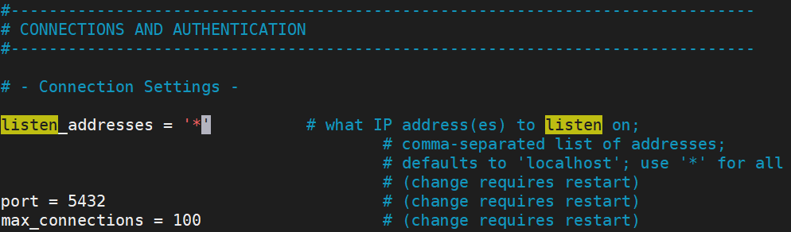

Listen addresses=’*’, port = 5432

1. Restart PostgreSQL service
2. Insert the PostgreSQL cli : sudo su – postgres
3. Create the relevant staff :
   1. **Create a database :** CREATE DATABASE jiradb WITH ENCODING 'UNICODE' LC_COLLATE 'C' LC_CTYPE 'C' TEMPLATE template0;
   2. Create a User : createuser --interactive –pwprompt jira
   3. Ensure that the user has permissions to connect to the database, and to create and write to tables in the database : GRANT ALL PRIVILEGES ON DATABASE jiradb TO jira
4. Restart PostgreSQL service
5. Make sure the data created successfully
6. Connect PostgreSQL to the Atlassian product